2 Minute Form
Trip Name: Whangarei’s Islands – Limestone (Matakohe) & Motukiore
Check-in Name and Phone: Ian Henderson 021 131 5513
Date: 24 – 26 July 2015 Branch: North Shore
Leaders | Ruth Henderson |  |  |  | Renee Olivier
Cell Phone Number | 021 298 8120 |  |  |  | 021 1081675
VHF Call Sign &/or Vessel Name | Rudolph ZMS 4968 |  |  |  | Flower Power ZMT 4802
Vehicle make, model, registration, colour | Toyota Corolla SW CFT347
General Plan  Note: If plan changes, you must notify your Check-in person. | Explore the historic Limestone Island ( www.limstoneisland.org.nz/) in the Whangarei Harbour one day, climb a pa site and enjoy a pub lunch at Parua on the other day. Base camp at Ruakaka Beach Holiday Park. Book your own cabin (fridge/jug/toaster BYO linen) from $60 /2 or tent site $32.50/2. Single rates may apply in winter. 094327590. Cook your own dinners in the communal kitchen.  Fri eve: meet at camping ground kitchen for chin-wag and to confirm plans. (Make Plan B plans if necessary.)  Sat: launch at One Tree Point 10.30. Paddle along the coast 2hrs, wander around the Limestone island, then on the outward tide head ‘home’. (23km)  Sun: Pack up camp, launch at same place and time but cross to Motukiore Is for a view from the pa site out to Marsden Point, Bream Head, and the Hen & Chickens, continue around to Parua for lunch. (19km)
Latest Time Off the Water | 1630 |  |  |  | TMP used²⁰ | New + Whangarei
Tide/ Forecast Lake Level | Low |  |  | Sat: Marsden Pt. 1400 2.3 High | Other
Communications Carried²¹ | VHF and Cellphone
Communications | We will be communicating as a group on VHF Channel __8___
Equipment Carried | Usual kayaking and safety gear plus extra thermals. Wheels a good idea.
Trip Report
(Use other side if more space required)

Activity |  |  | Sea kayaking |  |  |  | Centre | North Shore |  | Location Whangarei Harbour |  |  |  |  |  |  | Difficulty¹ |  |  |  |  | Strong beginner -intermediate
Activity Description |  |  | Explore Limestone Island launch at One Tree Point, Ruakaka. (23km)  Explore Parua Bay, Motukiora Island and pub (19km) |  |  |  |  |  |  |  | Leader qualification req.² |  |  |  | Sea kayak
Get in Location |  |  | One Tree Point |  |  |  |  |  |  |  | Chart/ Map no.⁴ |  |  |  | AX30 AX31 |  | Distance |  |  |  |  | 23 + 19 km
Get out Location |  |  | One Tree Point |  |  |  |  |  |  |  | Coastguard Channel |  |  |  | 83 & 16 |  | Nowcasting |  |  |  |  | 21
Emergency get out ⁵ |  |  | Many places along the coast |  |  |  |  |  |  |  | Emergency / Coastguard Station |  |  |  | Whangarei |  | Phone |  |  |  |  | *500  09 303 4303
 |  |  |  |  |  |  |  |  |  |  | Drinking Water⁶ |  | At camp |  |  | Toilets⁷ |  |  |  |  | At launch site; Limestone Is; Parua Pub.
Emergency Response |  |  | Refer Emergency Response Booklet |  |  |  |  |  |  |  |  |  |  |  |  | Parking⁸ |  |  |  |  | At One Tree Pt
Specific Equipment Required⁹ |  |  |  |  |  |  |  |  |  |  | Working Communications equipment in this area¹⁰ |  | Cell phone  Sat phone |  |  |  |  |  | Mountain Radio |  |  |  | PLB  VHF
Other resources  and notes¹¹ |  |  |  |  |  |  |  |  |  |  | Weather Parameters¹² |  | 15 -20knots
Previous incidents¹³
Safety Management¹⁴
Hazard |  | Significant?  - E/I/M |  |  | Management Strategy¹⁵ |  |  |  |  |  | Hazard | Significant?  - E/I/M |  | Management Strategy¹⁵
Cold Water |  | Yes - M |  |  | Carry spare dry clothes and shelter |  |  |  |  |  | Deep Water | Yes - E |  | Correctly fit PFDs
Medical Conditions |  | Yes - M |  |  | - Leader has first aid qualification  - Ask customers about medical conditions |  |  |  |  |  | Bad Weather | Yes - M |  | Understand weather forecasts.  Have back up plans or pull out if necessary
Capsizing |  | Yes - M |  |  | - Correctly fit PFDs  - Skills at performing rescues. |  |  |  |  |  | Heat / Sun | Yes - M |  | - Protective Clothing (worn), Sunglasses, Hat  - Sun Screen  - Plenty of drinks
Panic |  | Yes - M |  |  | Ensure conditions match level  of skills |  |  |  |  |  | Obstacles | Yes - M |  | Awareness of reefs, navigational hazards, nets
Other Hazards |  |  |  |  |  |  |  |  |  |  | Other Vessels | Yes - M |  | - Understand the “rules of the sea”  - “Be seen” – Have two of the following; flag, brightly coloured kayak, brightly coloured Pfd or hat. At night: an all- round white light & a powerful torch.
Other Hazards |  |  |  |  |  |  |  |  |  |  | Other Hazards
Written up by: | Ruth E. Henderson |  |  | Approved By: |  | James Fitness |  |  | Signed: | JF |  | Date: |  | 13/5/2016 |  |  |  | Review in: |  | 12 months from date of approval

Additional Information Sheet (Optional)
Introduction (A general introduction)
Description (A description of the tour – as if you were selling the idea to someone)
Local Attractions |  | Transport/ Local Operators
Harbour Basin | Contact details |  | Contact details
Clock Museum
Local Eateries
 | Contact details
Accommodation/ Campsite Locations |  |  | Facilities
Name | Ruakaka Holiday Park |  | Cabins | y | Fuel
Phone | 094327590 |  | Showers | y | Power | y
E-mail |  |  | Toilets | y | Water Access | no
Website |  |  | Laundry | y | Pool
Physical Address | 21 Ruakaka Beach Rd |  | Water | y | Fires Allowed
Other |  |  | Supplies
Other information

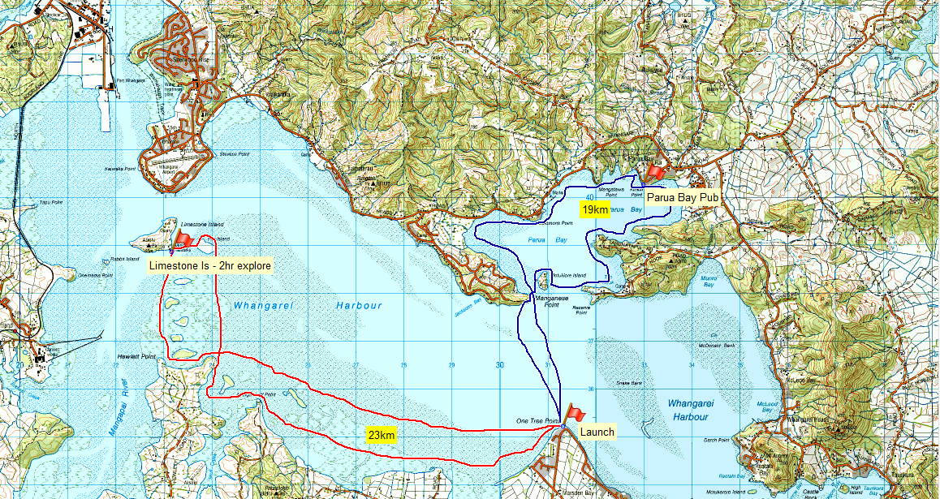

Activity Equipment Check list
Equipment List
- Helmet (rivers & surf) Group Gear
❑ Beanie / hat  Split paddles
❑ Thermals  Repair kit
❑ Paddle Jacket  Fire lighting
❑ PFD  Cooker/thermos
❑ Spray deck  Spare thermals
❑ Booties  Tow system
❑ Water & food  1st Aid Kit
❑ Kayak & paddle  Flares
Group - Oceans & Lakes  Compass
❑ Pumps & Paddle Floats  Charts / Maps
Group - River  GPS (optional)
❑ Throw ropes  Knife (cut rope)
❑ Pin kit & saw  Emergency Shelter

In case of emergency: Dial 111, Mayday :VHF Channel 16

Kayaking Check list

❑ Trip plan
❑ Latest weather forecast
❑ Conditions match skills?
❑ Hyperthermia (hot) &
Hypothermia (cold)
❑ On & off water safety
❑ Environmental concerns
❑ Emergency Procedures include emergency get out.
❑ Working communication devices
e.g. VHF radio, mobile phones, PLB
❑ Specific safety issues for this trip
❑ Participant list
❑ Any medical conditions
❑ All participants keen to proceed?

❑ Trip Plan/ 2-minute form lodged with Ops. Manager

Appropriate wind conditions to run trips:
Novice - no significant surf or swell, wind under 15knots
Intermediate- surf or ocean swells less than 1.5 meter or wind under 25 knots.
Advanced- any condition that is suitable to the trips aims

At conclusion of trip:
Contact check in person
Group Debrief.

Check in Person Ph:
__________________ Mobile
__________________ Work
__________________ Home

Activity Document Cover Sheet

Activity:
Date of Activity:

Activity reports. Is all relevant information present:
– Approved Trip Management Plan (TMP)/ 2 minute form
– Club Trip Participant Sheet
– Weather forecast
– Activity Check List
– Trip report (May be on the 2 minute form)
– Accident / incident reports
Leaders Signature:
Date:

